**Project Report On**

### Implementing CRM For Result Tracking Of A Candidate With Internal Marks (DEV)

**Milestone -01: Creation Of Developer Org**

Go to  developers.salesforce.com/

      Click on sign up.  
        On the sign up form, enter the following details :

1. First name & Last name – YACHAM SUJATHA
2. Email – yachamsujatha2003@gmail.com
3. Role : Developer
4. Company : Gayatri Degree College
5. County : India
6. Postal Code : 517501
7. Username : sujatha@gdcproject.com

**Account Activation**

Go to the inbox of the email that you used while signing up. Click on the verify account to activate your account. The email may take 5-10mins, as

# 

# Login To Your Salesforce Account

1. Go to salesforce.com and click on login.

2.Enter the username and password that you just created.

3. After login this is the home page which you will see.

### 

### Milestone -02 : Objects Creation

### Creation Of Semester Object For Candidate Internal Result Card

1. Click on the gear icon and then select Setup.

2. Click on the object manager tab just beside the home tab.

3. After the above steps, have a look on the extreme right you will find a Create Dropdownclick on that and select Custom Object.

4. On the Custom Object Definition page, create the object as follows:

5. Label: Semester

6. Plural Label: Semesters

7. Record Name: Semester Name

8. Check the Allow Reports

9. Check the Allow Search

10.Click Save.

In the same way create **4**more objects as **Candidate**, **Course Details**, **Lecturer Details** and **Internal results**.

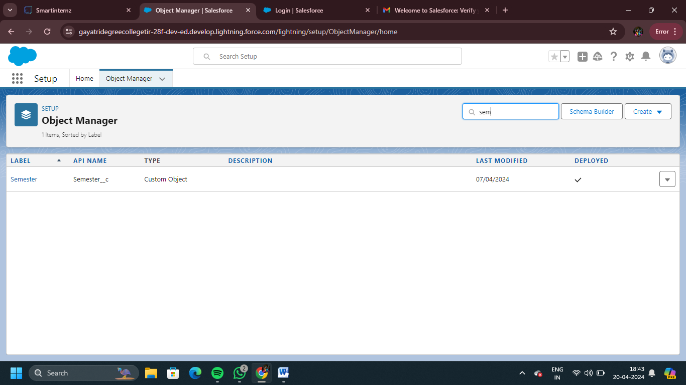

### Milestone – 03 : What Is A Tab?

### Creation Of Semester Tab For Candidate Internal Result Card

Now create a custom tab. Click the Home tab.

1. Enter Tabs in Quick Find and select Tabs.

2. Under Custom Object Tabs, click New.

3. For Object, select Semester.

4. For Tab Style, select any icon.

5. Leave all defaults as is. Click Next, Next, and Save

6. In the same way create Tabs for all Custom Objects -Candidate, Course Details, Lecturer Details, Internal results .

### 

### Milestone – 04 : Lightning App

### Create The Candidate Internal Result Card App

1. From Setup, enter App Manager in the Quick Find and select App Manager.

2. Click New Lightning App.

3. Enter **Candidate Internal Result Card** as the App Name, then click next

4. Under App Options, leave the default selections and click next.

5. Under Utility Items, leave as is and click Next.

6. From Available Items, select **Semester**, **Candidate**, **Course Details**, **Lecturer Details**, **Internalresults**, **Reports**, and **Dashboards** and move them to Selected Items.

7. Click Next.

From Available Profiles, select System Administrator and move it to Selected Profiles. Click Save & Finish.

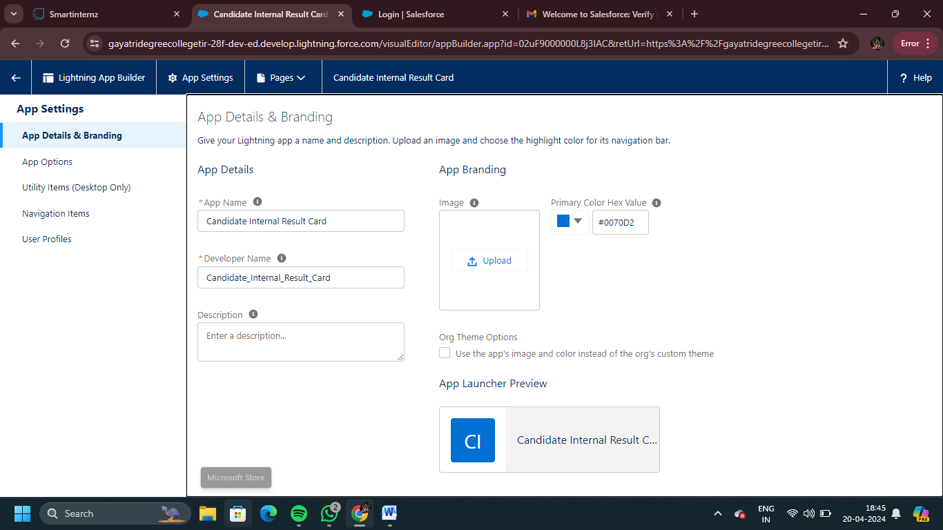

### Milestone – 05 : Fields And Relationship

### Creation Of Text Field On "Lecturer Details" & Look Up Field For The “Candidate” Object

1.Click the gear icon and select Setup. This launches Setup in a new tab.

2. Click the Object Manager tab next to Home.

3. Select Lecturer Details

4. Select Fields & Relationships from the left navigation

5. Click New

6. Select the Text as the Data Type, click next.

7. For Field Label, enter Lecturer Role

8. Enter Length 40

9. Click Next, Next, then Save & New.

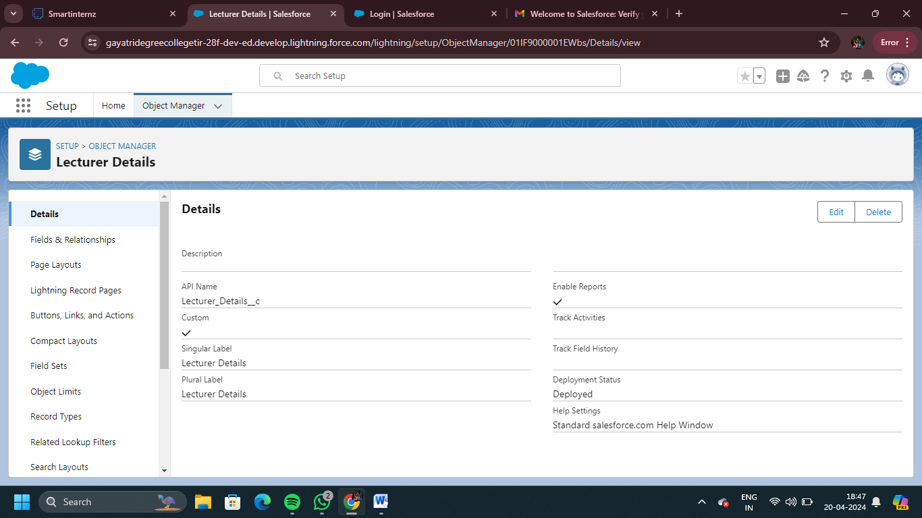

### Creation Of Auto Number Field On Candidate Object, Number Field On Course Details Object & Formula Field Course Details Object

Let’s create a Number field on Course Details object

1. Click the gear icon and select Setup. This launches Setup in a new tab.

2. Click the Object Manager tab next to Home.

3. Select Course Detail.

4. Select Fields & Relationships from the left navigation

4. Click New & select number field, click Next

6. For Field Label Duration, enter.

7. Give Help Text- Enter Course duration value in Years

8. Click Next, Next, then Save & New.

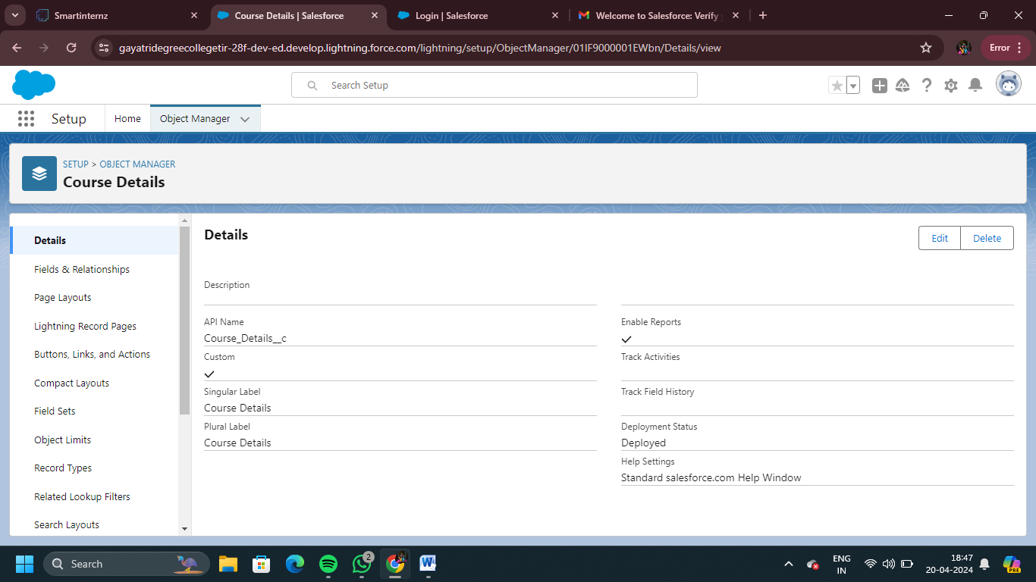

### Milestone – 06 : Users

### Creating A User

1. From Setup, in the Quick Find box, enter Users.

2. Select Users.

3. Click New User.

4. Enter the First Name, Class, Last Name, Teacher and (Your) email address anda unique username in the form of an email address. By default, the username is the same as the email address.

5. Select a User License as salesforce.

NOTE- As Salesforce license can only be used by 2 Users at a time in Dev Org, so If you don’t find salesforce license then deactivate a user who has salesforce license Or change the license type from Salesforce to any other.

6. Select a profile as Standard user.

7. Check Generate new password and notify the user immediately to have the user’s login name and a temporary password emailed to your email.

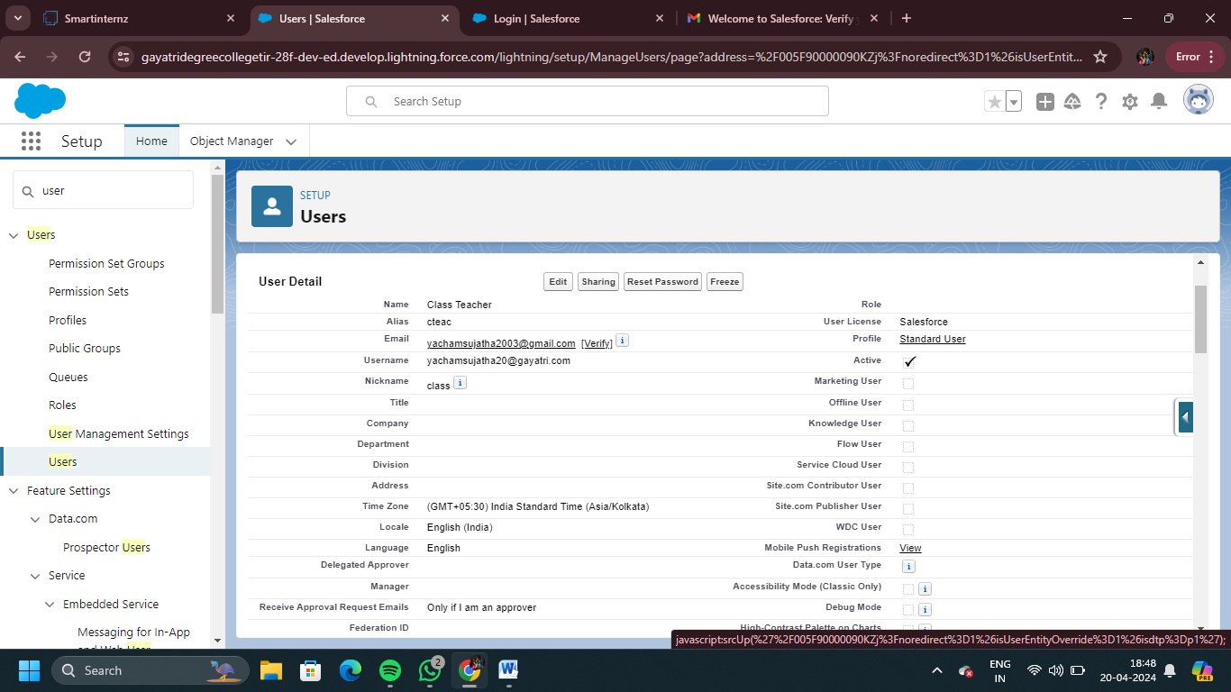

### Milestone – 07 : User Adoption

### Create Record (Course Details)

Create Records on Course Details Objects

1. Click on App Launcher on left side of screen.

2. Search Candidate Internal Result Card App & click on it.

3. Click on Course Details tab.

4. Click new button

5. Fill all Course Details record details.

6. Click on Save Button.

### 

### View Record (Course Details)

Viewing the Records of Course Detail Object

1. Click on App Launcher on left side of screen.

2. Search Candidate Internal Result Card & click on it.

3. Click on Course details Tab.

4. Click on any record name. you can see the details of the Driver

### 

### Delete Record (Course Details)

Deleting Records of Course Details Object

1. Click on App Launcher on left side of screen.

2. Search Candidate Internal Result Card & click on it.

3. Click on Course details Tab.

4. Click on Arrow at right hand side on that Particular record.

5. Click delete and delete again.

### Milestone – 08 : What Are Reports?

### Create Report

1. Click App Launcher

2. Select Candidate Internal Result Card App

3. Click reports tab

4. Click New Report.

5. Click the report type as Semesters with Course Click Start report.

6. Customize your report, in group rows select - Course Name, in group column Select Duration (In this way we are making a Matrix Report).

7. Click refresh

8. Click save and run

9. Give report name – Candidate Internal Result Report

10.Click Save

NOTE: In this report you can see your all record of the object you selected for reporting (What you Selects in “Select a report type option”).

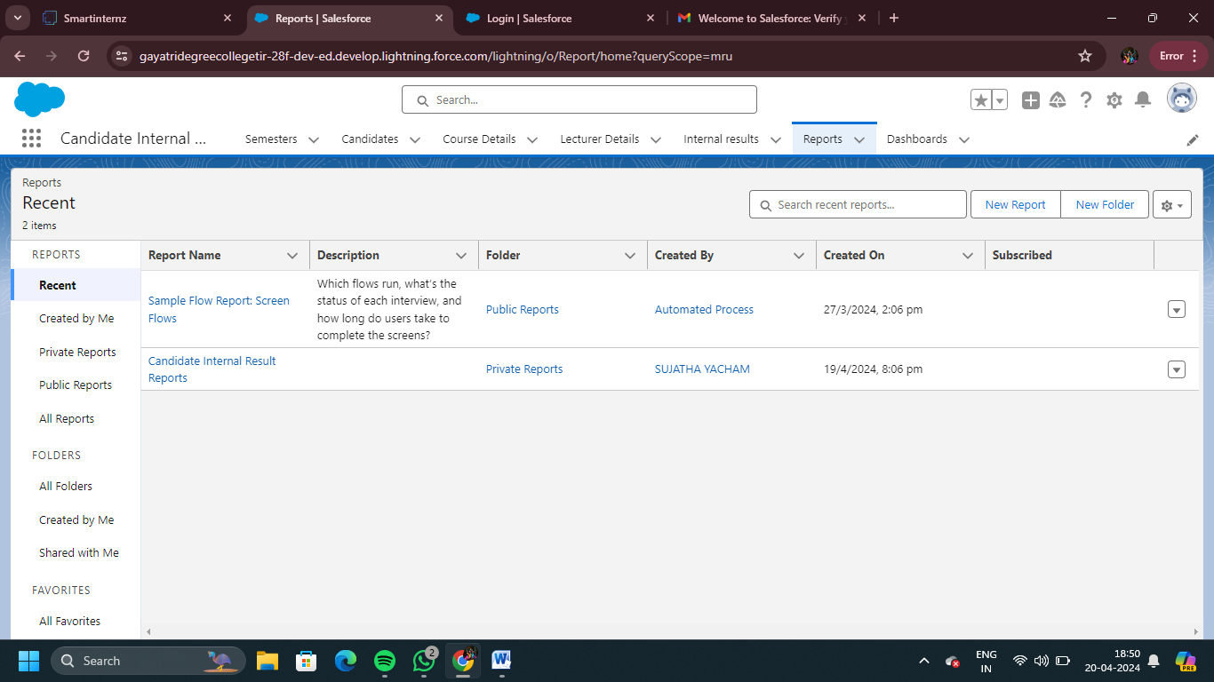

### View Report

1. Click on App Launcher on left side of screen.

2. Search Candidate Internal Result Card App & click on it.

3. Click on Reports Tab.

4. Click on Candidate Internal Result Report and see records.

### Milestone – 09 : Dashboards

### Create Dashboard

1. Click on Dashboards tab from the Candidate Internal Result Card application.

2. Click on new dashboard.

3. Give name- Candidate Internal Result Card

4. Click create

5.  Give your dashboard a name and click on +component

6. Select the Candidate Internal Result Report which you created.

7. For the data visualization select any of the chart, table etc. as per your choice/requirement.

8. Click add.

9. Click save.

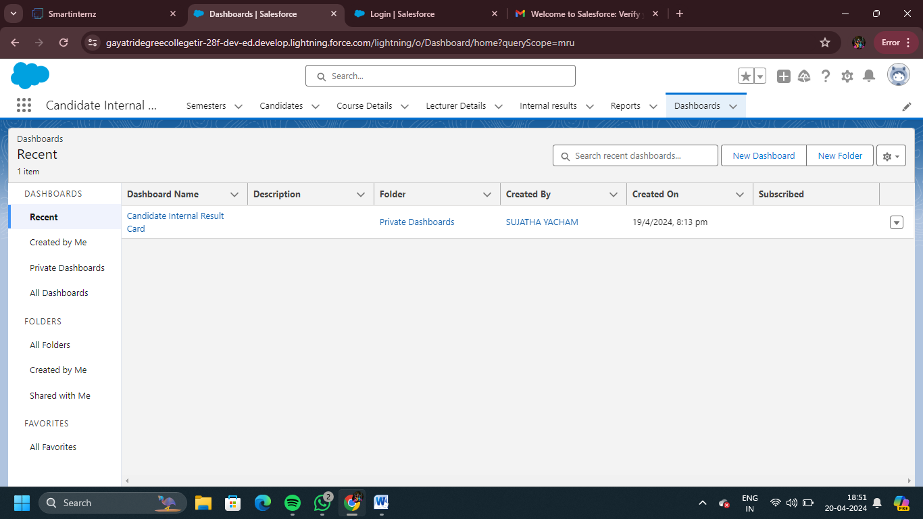

### View Dashboard

1. Click on App Launcher on left side of screen.

2. Search Candidate Internal Result Card & click on it.

3. Click on Dashboard Tab.

4. Click on Candidate Internal Result Card see graph view of records

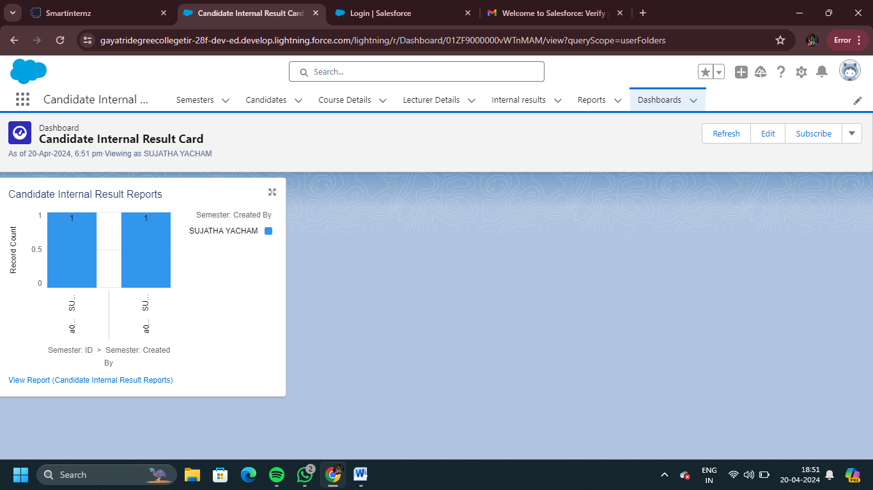

### Milestone – 10 : Screen Flow

### Create A Screen Flow

1. Click on Gear icon and select setup
2. In Quick find Box enter flow and select the flows
3. Click on New flow and Select Screen flow
4. It will open the canvas. Select (+)
5. Select the screen element from the drop down.
6. It will open the dialog box. Now give the label name and api name will be auto populated. These labels are for your screen Element.

 Label: Candidate info

   API Name: Candidate_Info (This field will be auto populated.)

1. In search Component type text and drag the text component to canva and give the label and Api Name
2. Similarly, Add Email Component also.
3. Select (+)
4. In search bar search for Create records and select the create records
5. It will open you the details section and give the label as follows:

Label: Create candidate Records

     API Name: Create_candidate_Records

     Then check the use separate resources and literal values Search for candidate Object

1. Under field type name and select the name and select the candidate_name under Screen Component
2. Click on Done
3. Click on Save. It will open you details canva and give the details as follows:
4. Select (+)
5. Select the Action  element from the drop down.
6. Enable Body and Give Hi {!Candidate_Name}, Welcome to the semester
7. Enable Recipient Address List and Give {!Email.value}
8. Enable Subject and Give Welcome

Flow label: Candidate flow

Flow API Name: Candidate_flow (this will be auto populated)

1. Click on save
2. Click on the Activate.

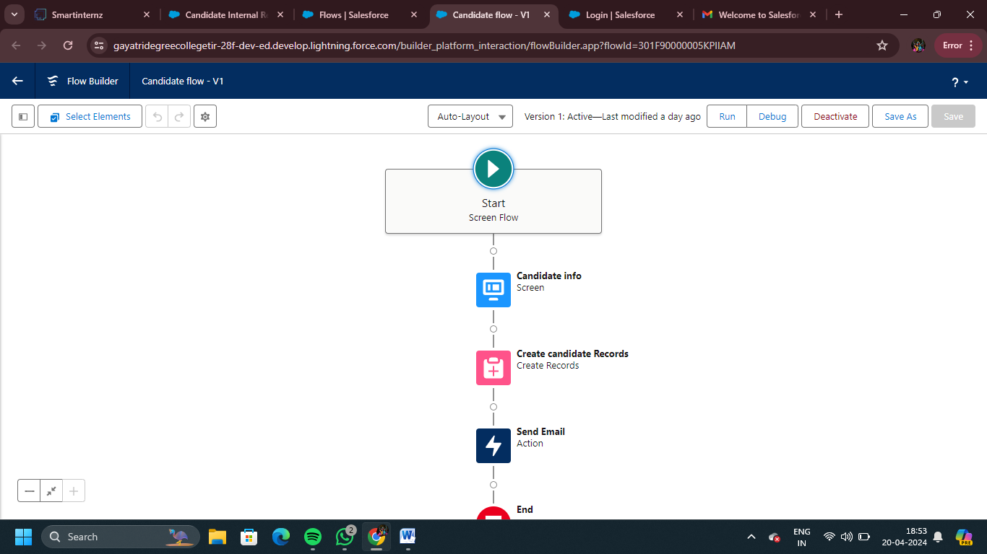

Milestone – 11 : App Page

### Create An App Page

1. Click on the Gear icon and select set up.

2. In Quick Find Box . Type app Builder and select the lighting app builder

3. Select New

4.Select the App page and click on Next

5. Give the label Name.

Label Name: Candidate App page.

6.Select the one region and click on finish

.

7.Type the flow in the search bar and select the flow component and drag the component to the Add components here.

8. After dragging the component, give the flow label in the flow search and then click on save and then click on activate. Flow label:Candidate flow

9. After clicking on the activate it will open a page and then select the lightning experience and select the app and then click on add page to the app.

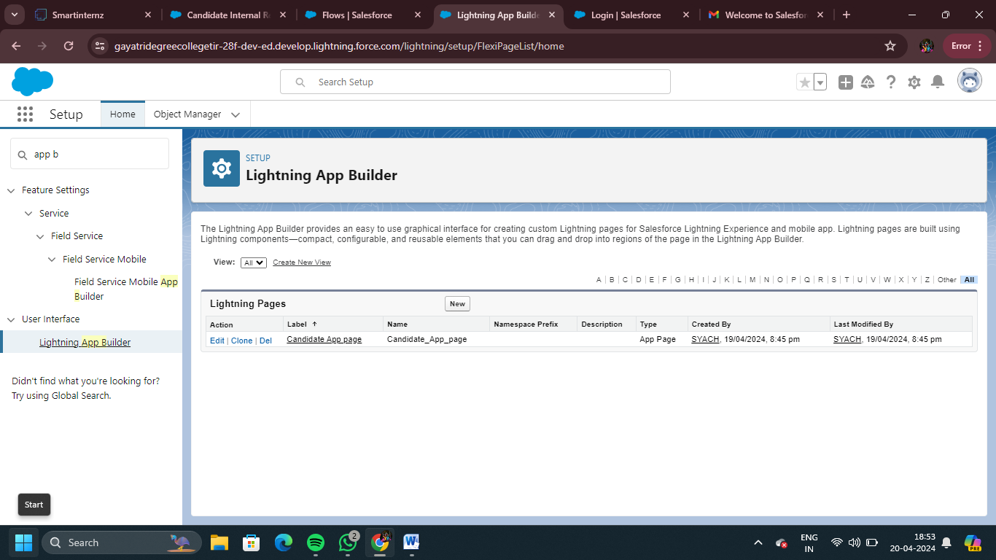

Milestone – 12: Triggers

### Field Update Using Trigger

Whenever a internal Marks is inserted if the marks is greater than or equal to 200 it must update the status field to Pass or else it must update to fail

1. Go to the gear icon and select the developer console.

2. From the menu bar click on file and select Apex class.

3. Now give the class name as InternalmarksHandler

4. Now Write the  below code

public class InternalmarksHandler {

    public static void beforeinsert(list<Internal_result__c> newlist){

        for(Internal_result__c internalmarks : newlist){

            if(internalmarks.marks__c >= 200){

                internalmarks.status__c = 'Pass';

            }else{

                internalmarks.status__c='fail';

            }

        }

    }

}

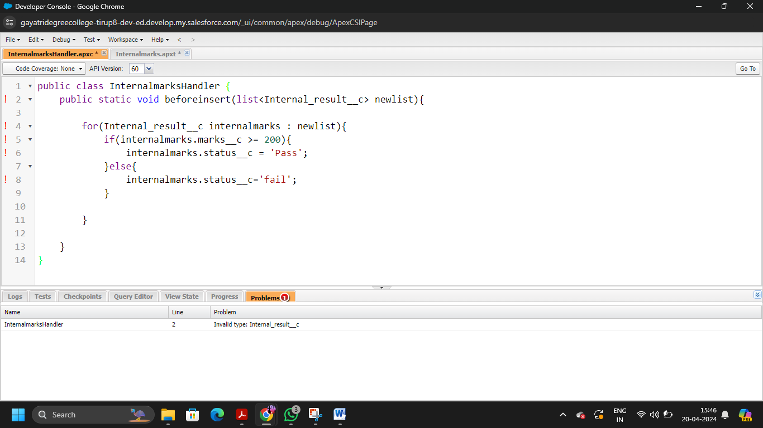

5. From the menu bar click on file and select Apex trigger.

6. Now give the trigger name as Internalmarks

7. Now write the below code

trigger Internalmarks on Internal_result__c(before insert,after update) {

    If(trigger.isInsert)

    {

        If(trigger.isBefore)

        {

            InternalmarksHandler.beforeinsert(Trigger.new);

        }

    }

}

8.Trigger Working as follows:  
   In the following record Marks field is given as 300,Now trigger triggers and  
   status changes to Pass

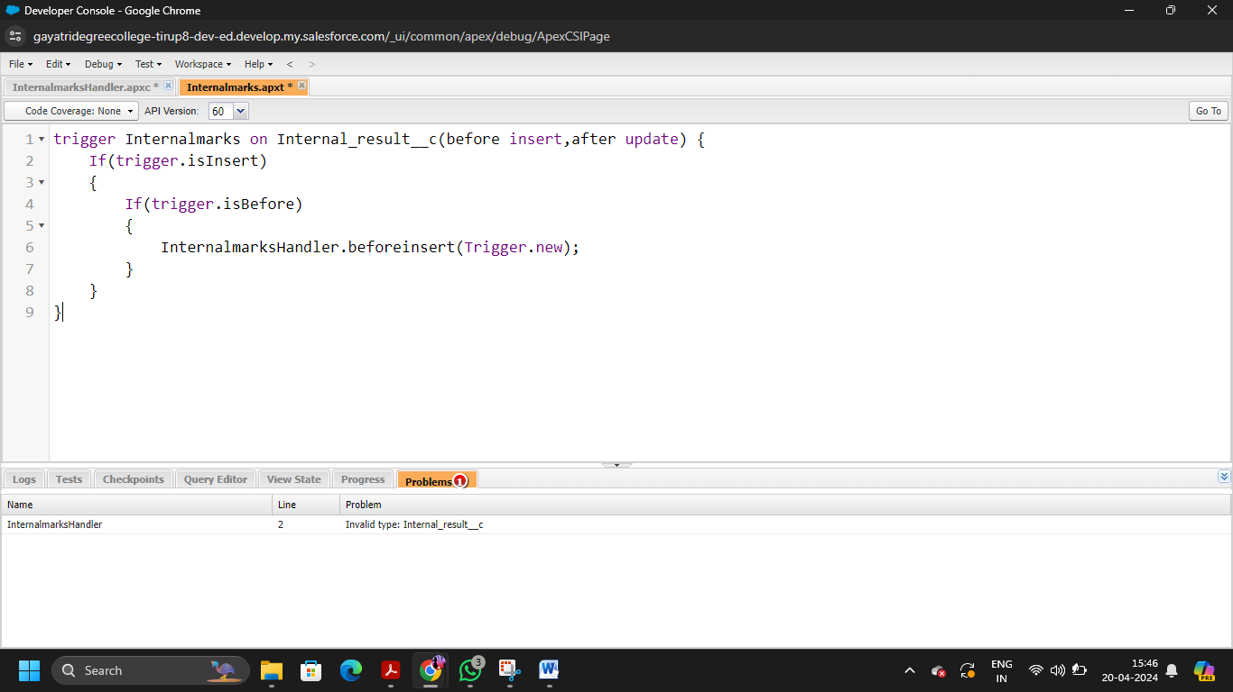

**THE END**

### 